**Healing The Land Ministries Website: Homepage Mockup & Project Progress**

**Prepared by:** Michael Jalmein  
**Date:** 15th October 2024

**Executive Summary**

The purpose of this document is to provide an update on the progress of the Healing The Land Ministries website project, specifically presenting the PC version mockup of the homepage. The website is being designed to support the ministry's mission by providing a platform for showcasing our initiatives, encouraging donations, and keeping the community informed.

This document includes an overview of the homepage mockup, along with links to other incomplete pages that are in progress. Please note that all images, including the logo, are placeholders. This proposal outlines the next steps to complete the project and invites feedback to ensure the work aligns with the ministry’s vision.

While the recent board meeting was intended to be a discovery session to gather information and align expectations, I took the initiative to develop a mockup after the fact. I am hopeful that it will come close to sufficing and will demonstrate the direction I envision for the site.

**Objectives**

The Healing The Land Ministries website will serve several key objectives:

1. **Showcasing Initiatives** – Highlighting our projects that focus on community development and spiritual transformation.
2. **Encouraging Support** – Providing a clear and user-friendly way for visitors to donate to our cause through the 'Support Us' page.
3. **Providing Important Updates** – Sharing the latest news and notices from HTL Ministries via the 'Notice Board' page.
4. **Honoring Our Founder** – Dedicating space on the 'About' page and the 'Library' to commemorate the legacy of our late founder.

**Deliverables to Date**

To date, I have completed the following:

* **Homepage Mockup (PC Version)**: The initial design for the homepage is complete. The design highlights the ministry’s key message in the hero section and provides clear navigation to other pages.
* **Placeholder Images**: All images on the site, including the logo, are placeholders and will be replaced with finalized content upon approval.
* **Navigation Links**: The homepage includes working links to the 'Support Us' page, 'Initiatives' page, 'Notice Board' page, and other planned sections, although content for these pages is still in development.
* **Planned Layout**: The homepage features sections that highlight upcoming notices, initiatives, and opportunities for community involvement.

You can view the mockup here: https://mike-startup.github.io/HTL/

**Features of the Homepage**

The homepage has been designed with the following features:

* 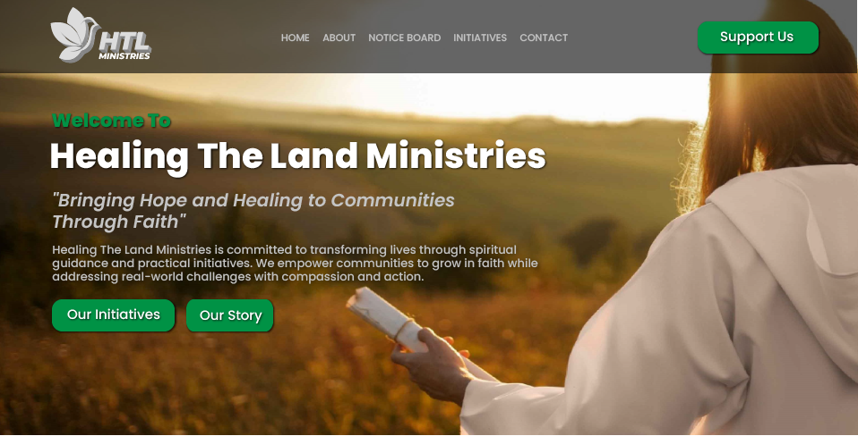**Landing Section**:

This section is the first thing visitors see when they land on a website, making it crucial for grabbing attention and setting the tone. A well-designed landing section for the homepage creates a strong first impression, directs user focus, and leads visitors toward the key actions you want them to take.

* 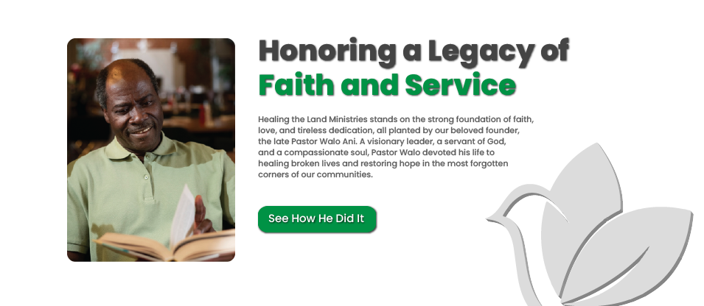**About Section:**

A dedicated section for the late Founder of HTLM will act as a doorway for visitors to explore more about the humble beginnings of the establishment.

* **Initiatives Section:**

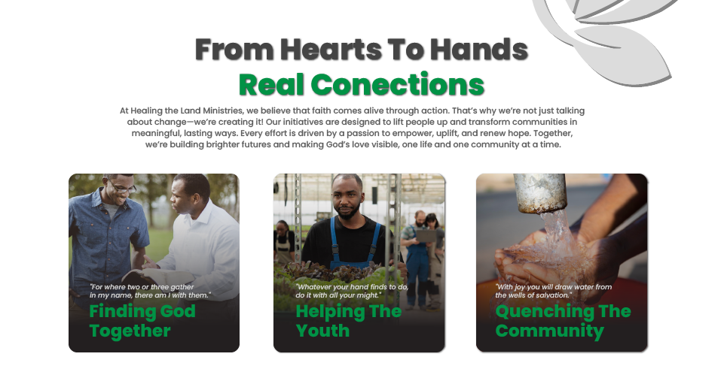

Featuring clickable cards and a call to action button, this section has links that lead visitors to the Initiatives page.

* 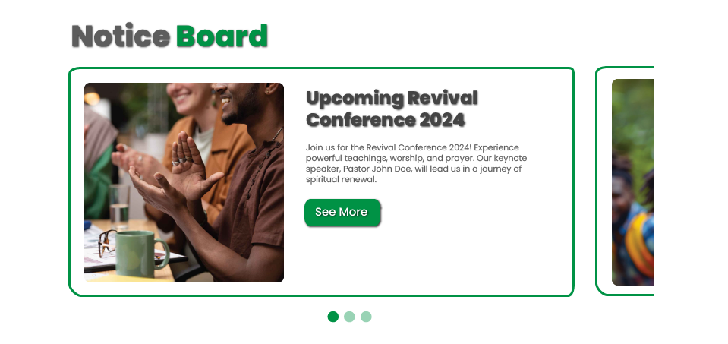**Notices Section**:

A rotating slider will highlight key announcements and updates, with each notice linked to the 'Support Us' page.

* **Library Section:**

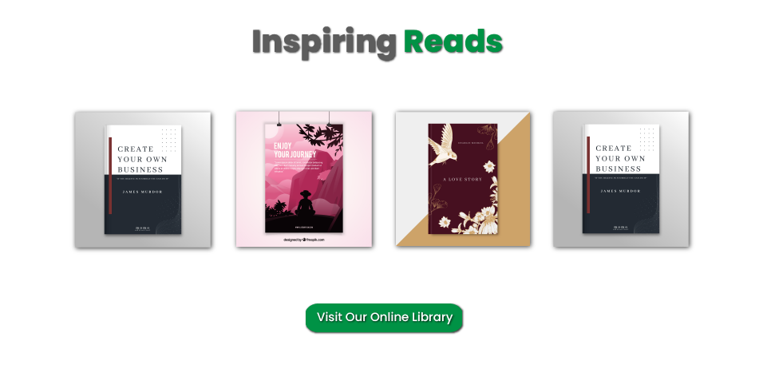This section is meant to showcase any written publication endorsed by HTLM.

* **Navigation Bar**:

Easy access to all pages of the site are made available both in the header and the footer.

**Next Steps**

Here’s an outline of the remaining tasks to complete the website:

1. **Custom Images** – Incorporate custom imagery into the site.
2. **Text content** – Finalize the text content.
3. **Support Us Page** – Finalize the design and content for the primary donation platform.
4. **Initiatives Page** – Create dedicated sections for each initiative, linking back to the 'Support Us' page.
5. **Notice Board Page** – Feature the latest news and updates, with links to the Support Us page’.
6. **Library Page** – Curate a selection of books sanctioned and endorsed by HTL Ministries either to showcase, sell or download and read.
7. **Mobile and Tablet Optimization** – Ensure that all pages are responsive and function smoothly on mobile and tablet devices.
8. **Feedback Implementation** – Incorporate any feedback provided by the team regarding the homepage and overall structure.

**Expected Timeline**

The below mentioned durations will become effective upon your deliberation of this opening dialogue. Hence, the successful completion of the above tasks will depend greatly on your subsequent feedback.

* Completion of remaining pages: 5 days.
* Final review and revisions: 2 days
* Website launch: [Discretion of HTLM]

**Challenges and Mitigations**

One of the primary challenges faced during the project was the lack of mutual planning and dialogue which was largely due to my unfavorable and untimely circumstances. However, I am confident that by continuing a healthy dialogue, the project will be brought to completion on-time and on-budget. I will be happy to address any adjustments that the team feels are necessary.

**Call to Action**

I invite the HTL Ministries team to review the attached homepage mockup and provide any feedback or suggestions. Your input will be invaluable as we finalize the remaining pages. Please keep in mind that all images are placeholders, and finalized imagery will be added in the next phase of development. I would appreciate the opportunity to schedule a follow-up meeting to discuss the next steps and confirm alignment on the final design.

Thank you for your ongoing support and trust in my work.

**Link to the Homepage Mockup website**

<https://mike-startup.github.io/HTL/>

*Note*:*The current version of the site can only be viewed using a pc.*